Minutes of the launch of Nomad of the Seas:

For those who were unable to attend the kickoff conference with Nomad of the Seas, La Paillaisse, Raphaël Schoentgen and Stephane Quéré, here is a summary of what happened:
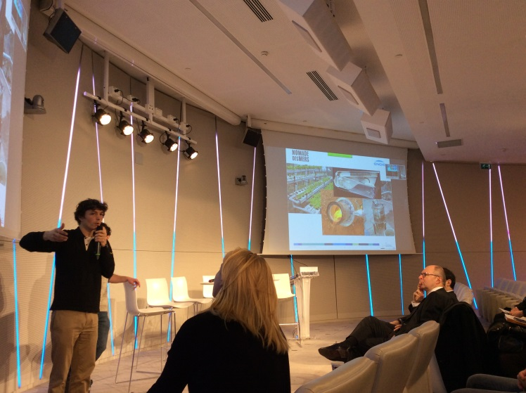
Corentin, the founder of the Nomad of the Seas project and president of the Gold of Bengal association.

What we call “low-tech” refers to technologies that meet basic needs and that can be manufactured all over the world.
Nomad of the Seas includes some examples of low-tech: a hydroponics system to grow plants with no soil and 10 times less water than standard practices, which was first developed by NASA and spread more widely; a thrifty wood stove, which consumes 7 times less wood than a standard model... Such low-tech devices can be developed by many kinds of people: entrepreneurs, tinkerers, even NASA…

Nomad of the Seas aims to meet needs related to self-sufficiency. These needs are shared by millions of people. The involve getting and keeping access to water, energy and food on "shoestring" budgets. Similar problems may be encountered on a boat, in a village in Bangladesh or in the African bush.
Nomad of the Seas believes the following: inventions that increase self-sufficiency are not shared widely enough, and there is not enough research in low-tech.

Access to electricity is one of the basic needs found in throughout the world, especially in developing countries. Low-tech can be used to address this issue

Nomad of the Seas includes a generator that can be manufactured anywhere in the world from copper wire, a car axle, and magnets that can be recovered from computers, for example ... and which can produce up to 200w.
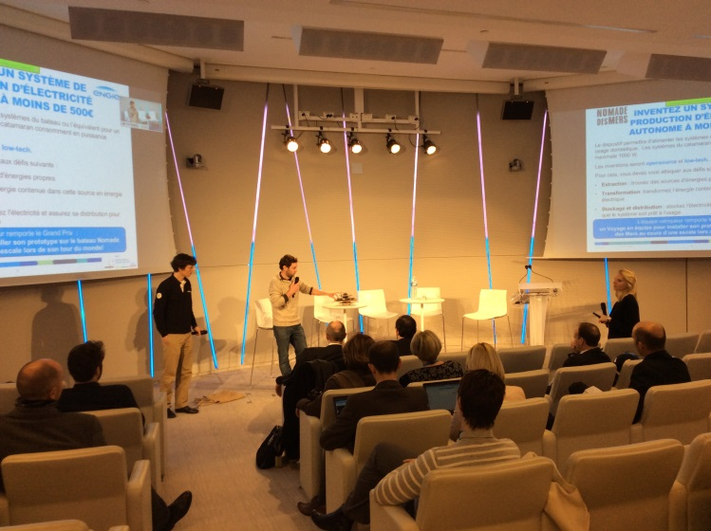
ENGIE is partnering with Nomad of the Seas in the challenge to "invent an electricity generation system for under €500". The goal is to boost research on low-tech devices for producing electricity.

Nomad of the Seas will then spread the word about the innovations during its sea voyage. Open-source technology is another feature of the challenge and also make it easier to share information about the inventions.

The winners of the ENGIE-sponsored challenge will join the team on the boat during one of their stopovers to install their invention. A video tutorial will also be made.

The detailed design phase will be held through January 27th, during which potential participants can put their teams together and think about the systems they want to create.
After that come the supply and prototyping phases, during which the teams will get €500 to produce their prototypes.
Throughout the process teams will get expert advice from Nomad of the Seas and ENGIE and support from La Paillasse in either Paris or Lyon.

The following organizations were involved in a roundtable discussion:
- Corentin from Gold of Bengal
- Thomas Landrian, founder and president of the "La Paillasse" hackerspace
As well as stakeholders from ENGIE:
- Stéphane Quéré, Director of Commercial Coordination, Communication and Partnerships in the Sales, Innovation and New Business Department
- Raphaël Schoentgen, Member of the Executive Committee, Director of Research and Technology and its partner Ideas Laboratory.
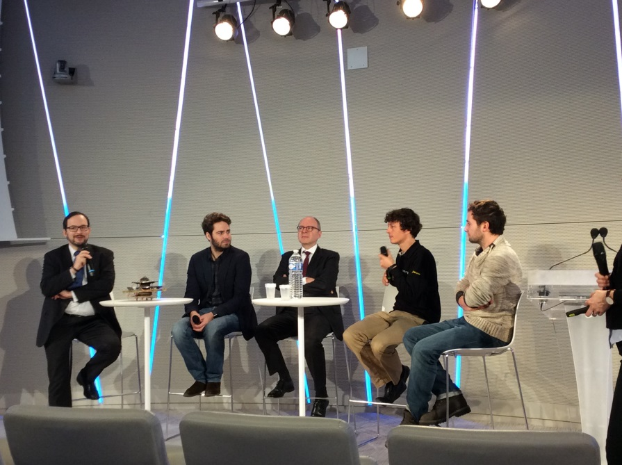
Adil Chenaf, who is in charge of support for BtoC, BtoB, and BtoT business for the Africa BU and Laure Vincotte, CEO of Rassembleurs d’Energie, are also involved in the challenge and will be members of the selection committee.

Raphaël Schoentgen gave details about the Research and Technology Department’s contributions to the project, which will include providing expert support to teams participating in the challenge.

Thomas Landrain then presented La Paillasse, which is a research laboratory for the era of collective intelligence, meaning a much more open one. La Paillasse will support the teams participating in the challenge by holding a protohackathon to prepare them for prototyping in particular.

Stephane Quéré reminded those in attendance that the challenge is open to all Group employees but also to anyone from outside the company who wants to participate.

Corentin said that the low-tech revolution may actually be able to take place if large companies like ENGIE put their industrial know-how to use developing low-tech devices.

Timothy Silvestre of Ideas laboratory said that "this challenge is about spreading the use of affordable technologies at an affordable cost."

Q+A about the Challenge:

Q: What about open source technologies? Can we use patents as part of the challenge?
A: The goal of the challenge is to promote open source solutions that will be shared for "do it yourself" purposes elsewhere. We’re looking for low-tech and simple things, so if there are patents on particularly interesting solutions, we should look at them look anyway. This could then lead to other processes for smaller power generation capacities or homemade production techniques that would be open.

Q: Would it be OK if the electricity generation system were to slow down the boat?
A: The boat is also a laboratory so there is no problem in using water currents, for example.

Q: How should employees manage their time for participating in the project?
A: As for the volunteers from the other organizations that are participating, you take part in the challenge on your own time, which is why space in La Paillasse locations in Paris and Lyon will be made available to you.

Q: What will the prize include?
A: ENGIE’s gift is to let the winning team install its invention on the boat.

Q: The project specs mention the need for 1000w of generation capacity and storage for 48 hours. Is it really necessary to store 48kWh and how long should it take to recharge the battery?
A: The specs are meant to serve as guidelines. The goal is to work towards an optimal and low-cost technical solution (for power, stored energy...). For example, you could imagine a situation in which there was no storage but in which electricity is continuously produced.

Q: Is there a maximum size for the team?
R: 5 people.

Q: Why you have not included university laboratories in the process?
A: That’s the purpose of the voyage around the world, which will take 3 years: the Nomad of the Seas will visit universities, fablabs, NGOs ...

Q: Why are you using video as a medium when internet connections in Africa are particularly bad?
A: There is no doubt about the growth of the Internet in emerging countries like as Bangladesh. YouTube and Facebook are increasingly accessible. On these social networks, video lets us share knowledge and skills. PDFs are less useful for sharing innovations. The Nomad of the Seas will use the tutorial videos to contact the initial project beneficiaries, who will themselves create a version of the innovation and share their own expertise in doing so. Most of the people who benefit from the project will therefore do so indirectly.

Q: Would it be possible to have a small boat trailing behind the main boat on which a solar technology system could be installed, for example?
A: Yes, no problem. It will even be possible to test the inventions during stopovers.

For further questions or to find teammates, please contact Claire and Emilie: claire.ducolombier@gdfsuez-fe.com and emilie.forster@engie.com.

The entire conference is available on video.

